Objective 1

DANA4820

2025-03-29

# Load required libraries  
library(dplyr)

## Warning: package 'dplyr' was built under R version 4.4.2

##   
## Attaching package: 'dplyr'

## The following objects are masked from 'package:stats':  
##   
## filter, lag

## The following objects are masked from 'package:base':  
##   
## intersect, setdiff, setequal, union

library(ggplot2)

## Warning: package 'ggplot2' was built under R version 4.4.2

library(binom)

## Warning: package 'binom' was built under R version 4.4.2

library(exactci)

## Warning: package 'exactci' was built under R version 4.4.2

## Loading required package: ssanv

## Loading required package: testthat

## Warning: package 'testthat' was built under R version 4.4.2

##   
## Attaching package: 'testthat'

## The following object is masked from 'package:dplyr':  
##   
## matches

##   
## Attaching package: 'exactci'

## The following object is masked from 'package:binom':  
##   
## binom.exact

library(PropCIs)  
library(epitools)

##   
## Attaching package: 'epitools'

## The following object is masked from 'package:exactci':  
##   
## binom.exact

## The following objects are masked from 'package:binom':  
##   
## binom.exact, binom.wilson

library(MASS)

##   
## Attaching package: 'MASS'

## The following object is masked from 'package:dplyr':  
##   
## select

library(car)

## Warning: package 'car' was built under R version 4.4.2

## Loading required package: carData

## Warning: package 'carData' was built under R version 4.4.2

##   
## Attaching package: 'car'

## The following object is masked from 'package:dplyr':  
##   
## recode

library(tidyr)

## Warning: package 'tidyr' was built under R version 4.4.2

##   
## Attaching package: 'tidyr'

## The following object is masked from 'package:testthat':  
##   
## matches

# Read the dataset  
df <- read.csv('global_health.csv')  
str(df)

## 'data.frame': 1880 obs. of 29 variables:  
## $ Country : chr "Afghanistan" "Afghanistan" "Afghanistan" "Afghanistan" ...  
## $ Country_Code : chr "AFG" "AFG" "AFG" "AFG" ...  
## $ Year : int 2012 2013 2014 2015 2016 2017 2018 2019 2020 2021 ...  
## $ Fertility_Rate : num 5.83 5.7 5.56 5.41 5.26 ...  
## $ Urban_Population_Percent : num 24.2 24.4 24.6 24.8 25 ...  
## $ Total_Population : num 30466479 31541209 32716210 33753499 34636207 ...  
## $ Water_Access_Percent : num 21.1 22 22.9 23.9 24.8 ...  
## $ Unemployment_Rate : num 7.91 7.92 7.92 9.01 10.1 ...  
## $ Sanitary_Expense_Per_GDP : num 7.9 8.81 9.53 10.11 11.82 ...  
## $ Life_Expectancy : num 61.9 62.4 62.5 62.7 63.1 ...  
## $ Life_Expectancy_Female : num 63.5 64 64.3 64.6 65.1 ...  
## $ Life_Expectancy_Male : num 60.3 60.8 60.8 60.8 61.2 ...  
## $ Infant_Deaths : num 70669 70906 70288 70068 69144 ...  
## $ GDP_Per_Capita : num 653 639 627 567 523 ...  
## $ Hospital_Beds_Per_1000 : num 0.47 0.46 0.46 0.44 0.45 0.42 0.4 0.38 0.34 0.36 ...  
## $ Female_Population : num 15067373 15594637 16172321 16682054 17115346 ...  
## $ Male_Population : num 15399105 15946572 16543889 17071446 17520861 ...  
## $ Alcohol_Consumption_Per_Capita: num 0.004 0.004 0.004 0.009 0.013 0.017 0.016 0.016 0.011 NA ...  
## $ Immunization_Rate : num 67 64 62 64 66 66 72 72 70 66 ...  
## $ Sanitary_Expense_Per_Capita : num 52.6 56.3 60.2 60.1 61.5 ...  
## $ CO2_Exposure_Percent : num 70.9 73.1 77.1 73.5 72.8 ...  
## $ Air_Pollution : num 70.9 73.1 77.1 73.5 72.8 ...  
## $ Labour_Force_Total : num 7520865 7881567 8285362 8630724 8913938 ...  
## $ Tuberculosis_Per_100000 : num 189 189 189 189 189 189 189 189 183 185 ...  
## $ Suicide_Rate_Percent : num 3.68 3.66 3.6 3.57 3.61 3.44 3.52 3.61 NA NA ...  
## $ Obesity_Rate_Percent : num 10.7 11.6 10.4 11.2 12 ...  
## $ Underweight_Rate_Percent : num 10.15 10.79 10.17 10.52 7.88 ...  
## $ Overweight_Rate_Percent : num 31.6 32.7 34 35.2 36.5 ...  
## $ Safe_Water_Access_Percent : num 46.7 49.5 52.2 55.1 58 ...

View(df)

# Clean and handle missing values  
colnames(df) <- trimws(colnames(df))  
df_clean <- df %>%   
 filter(!is.na(Life_Expectancy_Female) & !is.na(Life_Expectancy_Male)) %>%  
 mutate(across(where(is.numeric), ~ ifelse(is.na(.), median(., na.rm = TRUE), .)))  
  
num_cols <- sapply(df_clean, is.numeric)  
df_clean[num_cols] <- lapply(df_clean[num_cols], function(x) {  
 cap_value <- quantile(x, 0.99, na.rm = TRUE)  
 ifelse(x > cap_value, cap_value, x)  
})  
  
# Keep relevant variables  
df_clean <- df_clean %>%  
 dplyr::select(Country, Year, Life_Expectancy, Life_Expectancy_Female, Life_Expectancy_Male,  
 GDP_Per_Capita, Unemployment_Rate, Safe_Water_Access_Percent, Urban_Population_Percent,  
 Immunization_Rate, Air_Pollution, Infant_Deaths) %>%  
 group_by(Country) %>%  
 mutate(across(where(is.numeric), ~ ifelse(is.na(.), median(., na.rm = TRUE), .))) %>%  
 ungroup() %>%  
 filter(complete.cases(.))  
  
# Categorize Life Expectancy by Gender  
df_clean <- df_clean %>%  
 mutate(Life_Expectancy_Category_Female = case_when(  
 Life_Expectancy_Female < 60 ~ 'Low',  
 Life_Expectancy_Female >= 60 & Life_Expectancy_Female < 75 ~ 'Medium',  
 Life_Expectancy_Female >= 75 ~ 'High'  
 ),  
 Life_Expectancy_Category_Male = case_when(  
 Life_Expectancy_Male < 60 ~ 'Low',  
 Life_Expectancy_Male >= 60 & Life_Expectancy_Male < 75 ~ 'Medium',  
 Life_Expectancy_Male >= 75 ~ 'High'  
 ))

## Objective 1: Differences in Life Expectancy Between Genders  
  
# Frequency table for Female  
lifeexp_table_f <- table(df_clean$Life_Expectancy_Category_Female)  
lifeexp_table_f

##   
## High Low Medium   
## 1002 99 739

# Frequency table for Male  
lifeexp_table_m <- table(df_clean$Life_Expectancy_Category_Male)  
lifeexp_table_m

##   
## High Low Medium   
## 438 284 1118

# Count frequencies   
lifeexp_table <- table(Gender = rep(c("Female", "Male"), each = nrow(df_clean)),  
 Category = c(df_clean$Life_Expectancy_Category_Female, df_clean$Life_Expectancy_Category_Male))  
lifeexp_table

## Category  
## Gender High Low Medium  
## Female 1002 99 739  
## Male 438 284 1118

# Wald Test  
wald_test <- function(y, n, p){  
 p_hat <- y/n  
 se <- sqrt(p_hat * (1 - p_hat) / n)  
 z <- (p_hat - p) / se  
 pvalue <- 2 * pnorm(abs(z), lower.tail=FALSE)  
 return(c('Z-Statistic' = z, 'P-Value' = pvalue))  
}  
wald_test(lifeexp_table[1,3], sum(lifeexp_table[1,]), 0.5)

## Z-Statistic P-Value   
## -8.607393e+00 7.474118e-18

# Score Test  
score_test <- prop.test(c(lifeexp_table[1,3], lifeexp_table[2,3]),  
 c(sum(lifeexp_table[1,]), sum(lifeexp_table[2,])),  
 alternative = 'two.sided')  
score_test

##   
## 2-sample test for equality of proportions with continuity correction  
##   
## data: c(lifeexp_table[1, 3], lifeexp_table[2, 3]) out of c(sum(lifeexp_table[1, ]), sum(lifeexp_table[2, ]))  
## X-squared = 155.32, df = 1, p-value < 2.2e-16  
## alternative hypothesis: two.sided  
## 95 percent confidence interval:  
## -0.2381366 -0.1738200  
## sample estimates:  
## prop 1 prop 2   
## 0.4016304 0.6076087

# Likelihood Ratio Test  
likelihood_ratio_test <- function(phat, pnull, y, n) {  
 LL <- c(  
 'LRT Statistic' = 2 * log(dbinom(x = y, prob = phat, size = n) / dbinom(x = y, prob = pnull, size = n)),  
 'P-Value' = pchisq(2 * log(dbinom(x = y, prob = phat, size = n) / dbinom(x = y, prob = pnull, size = n)), 1, lower.tail = FALSE)  
 )  
 return(LL)  
}  
likelihood_ratio_test(phat = 0.5, pnull = 0.5, y = lifeexp_table[1,3], n = sum(lifeexp_table[1,]))

## LRT Statistic P-Value   
## 0 1

# Chi-Square Test  
chi_test <- chisq.test(lifeexp_table)  
chi_test

##   
## Pearson's Chi-squared test  
##   
## data: lifeexp_table  
## X-squared = 387.61, df = 2, p-value < 2.2e-16

# Binomial Exact Test  
binom_exact_test <- binom.test(lifeexp_table[1,3], sum(lifeexp_table[1,]), p = 0.5, alternative = "two.sided")  
binom_exact_test

##   
## Exact binomial test  
##   
## data: lifeexp_table[1, 3] and sum(lifeexp_table[1, ])  
## number of successes = 739, number of trials = 1840, p-value < 2.2e-16  
## alternative hypothesis: true probability of success is not equal to 0.5  
## 95 percent confidence interval:  
## 0.3791312 0.4244439  
## sample estimates:  
## probability of success   
## 0.4016304

# Confidence Intervals (Wald, Wilson, Likelihood Ratio)  
wald_ci <- binom.confint(lifeexp_table[1,3], sum(lifeexp_table[1,]), conf.level = 0.95, method = "asymptotic")  
wilson_ci <- binom.confint(lifeexp_table[1,3], sum(lifeexp_table[1,]), conf.level = 0.95, method = "wilson")  
lrt_ci <- binom.confint(lifeexp_table[1,3], sum(lifeexp_table[1,]), conf.level = 0.95, method = "lrt")  
  
list(Wald_CI = wald_ci, Wilson_CI = wilson_ci, Likelihood_Ratio_CI = lrt_ci)

## $Wald_CI  
## method x n mean lower upper  
## 1 asymptotic 739 1840 0.4016304 0.379231 0.4240299  
##   
## $Wilson_CI  
## method x n mean lower upper  
## 1 wilson 739 1840 0.4016304 0.3794583 0.4242124  
##   
## $Likelihood_Ratio_CI  
## method x n mean lower upper  
## 1 lrt 739 1840 0.4016304 0.379385 0.4241535

# Proportional comparison barplot  
prop_df <- df_clean %>%  
 pivot_longer(cols = c(Life_Expectancy_Category_Female, Life_Expectancy_Category_Male),   
 names_to = "Gender", values_to = "Life_Category") %>%  
 group_by(Gender, Life_Category) %>%  
 summarise(Count = n(), .groups = 'drop') %>%  
 group_by(Gender) %>%  
 mutate(Proportion = Count / sum(Count))  
  
ggplot(prop_df, aes(x = Life_Category, y = Proportion, fill = Gender)) +  
 geom_bar(stat = "identity", position = "dodge") +  
 labs(title = "Proportion of Life Expectancy Categories by Gender", x = "Category", y = "Proportion") +  
 theme_minimal()

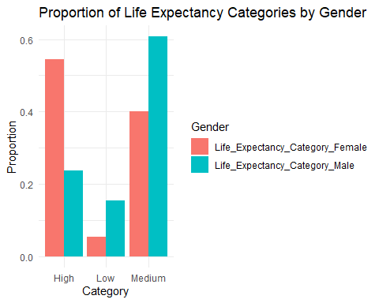

# Summary Stats Comparison  
summary_stats <- df_clean %>%  
 summarise(  
 Mean_Female = mean(Life_Expectancy_Female),  
 Mean_Male = mean(Life_Expectancy_Male),  
 Median_Female = median(Life_Expectancy_Female),  
 Median_Male = median(Life_Expectancy_Male),  
 SD_Female = sd(Life_Expectancy_Female),  
 SD_Male = sd(Life_Expectancy_Male)  
 )  
summary_stats

## # A tibble: 1 × 6  
## Mean_Female Mean_Male Median_Female Median_Male SD_Female SD_Male  
## <dbl> <dbl> <dbl> <dbl> <dbl> <dbl>  
## 1 74.1 68.9 76.1 69.3 8.10 7.71

# Paired T-Test between Male and Female Life Expectancy  
t_test <- t.test(df_clean$Life_Expectancy_Female, df_clean$Life_Expectancy_Male, paired = TRUE)  
t_test

##   
## Paired t-test  
##   
## data: df_clean$Life_Expectancy_Female and df_clean$Life_Expectancy_Male  
## t = 111.89, df = 1839, p-value < 2.2e-16  
## alternative hypothesis: true mean difference is not equal to 0  
## 95 percent confidence interval:  
## 5.111561 5.293961  
## sample estimates:  
## mean difference   
## 5.202761

# Density plot for Male and Female  
long_df <- df_clean %>%  
 dplyr::select(Country, Life_Expectancy_Female, Life_Expectancy_Male) %>%  
 pivot_longer(cols = starts_with("Life_Expectancy"), names_to = "Gender", values_to = "Life_Expectancy")  
  
long_df$Gender <- ifelse(grepl("Female", long_df$Gender), "Female", "Male")  
  
ggplot(long_df, aes(x = Life_Expectancy, fill = Gender)) +  
 geom_density(alpha = 0.5) +  
 labs(title = "Density Plot of Life Expectancy by Gender", x = "Life Expectancy", y = "Density") +  
 theme_minimal()

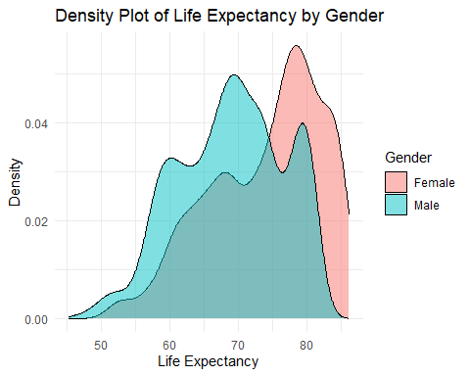

# ANOVA to compare Life Expectancy by Gender using long format  
anova_df <- df_clean %>%  
 dplyr::select(Country, Life_Expectancy_Female, Life_Expectancy_Male) %>%  
 pivot_longer(cols = c(Life_Expectancy_Female, Life_Expectancy_Male),  
 names_to = "Gender", values_to = "Life_Expectancy",  
 names_transform = list(Gender = ~ifelse(. == "Life_Expectancy_Female", "Female", "Male")))  
  
# Run one-way ANOVA  
anova_model <- aov(Life_Expectancy ~ Gender, data = anova_df)  
summary(anova_model)

## Df Sum Sq Mean Sq F value Pr(>F)   
## Gender 1 24903 24903 398.3 <2e-16 ***  
## Residuals 3678 229952 63   
## ---  
## Signif. codes: 0 '***' 0.001 '**' 0.01 '*' 0.05 '.' 0.1 ' ' 1

# 1. Side-by-Side Boxplots of Life Expectancy by Gender  
ggplot(long_df, aes(x = Gender, y = Life_Expectancy, fill = Gender)) +  
 geom_boxplot() +  
 labs(title = "Boxplot of Life Expectancy by Gender", x = "Gender", y = "Life Expectancy") +  
 theme_minimal()

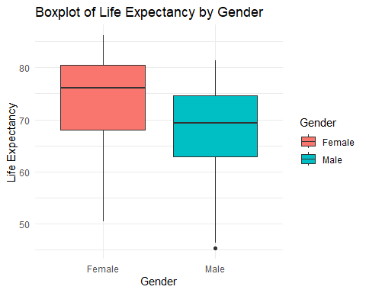

# 2. Line Plot of Life Expectancy Over Time by Gender  
df_long_time <- df_clean %>%  
 dplyr::select(Year, Country, Life_Expectancy_Female, Life_Expectancy_Male) %>%  
 pivot_longer(cols = starts_with("Life_Expectancy_"), names_to = "Gender", values_to = "Life_Expectancy") %>%  
 mutate(Gender = ifelse(Gender == "Life_Expectancy_Female", "Female", "Male"))  
  
ggplot(df_long_time, aes(x = Year, y = Life_Expectancy, color = Gender)) +  
 geom_line(stat = "summary", fun = mean) +  
 labs(title = "Average Life Expectancy Over Time by Gender", x = "Year", y = "Life Expectancy") +  
 theme_minimal()

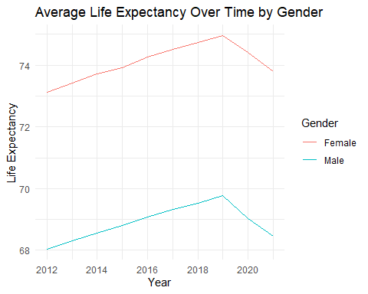

# 3. Heatmap of Life Expectancy by Country and Gender  
gap_df <- df_clean %>%  
 mutate(Gender_Gap = Life_Expectancy_Female - Life_Expectancy_Male)  
  
# 🔍 Improved Gender Gap Plot (Top 20 countries with largest gap)  
top_gap_df <- gap_df %>%  
 mutate(Gender_Gap = Life_Expectancy_Female - Life_Expectancy_Male) %>%  
 group_by(Country) %>%  
 summarise(Avg_Gap = mean(Gender_Gap, na.rm = TRUE)) %>%  
 arrange(desc(Avg_Gap)) %>%  
 slice(1:20)  
  
ggplot(top_gap_df, aes(x = reorder(Country, Avg_Gap), y = Avg_Gap)) +  
 geom_col(fill = "salmon") +  
 coord_flip() +  
 labs(title = "Top 20 Countries with Highest Gender Gap in Life Expectancy",  
 subtitle = "Positive values mean females live longer than males",  
 x = "Country", y = "Life Expectancy Difference (Female - Male)") +  
 theme_minimal(base_size = 12)

